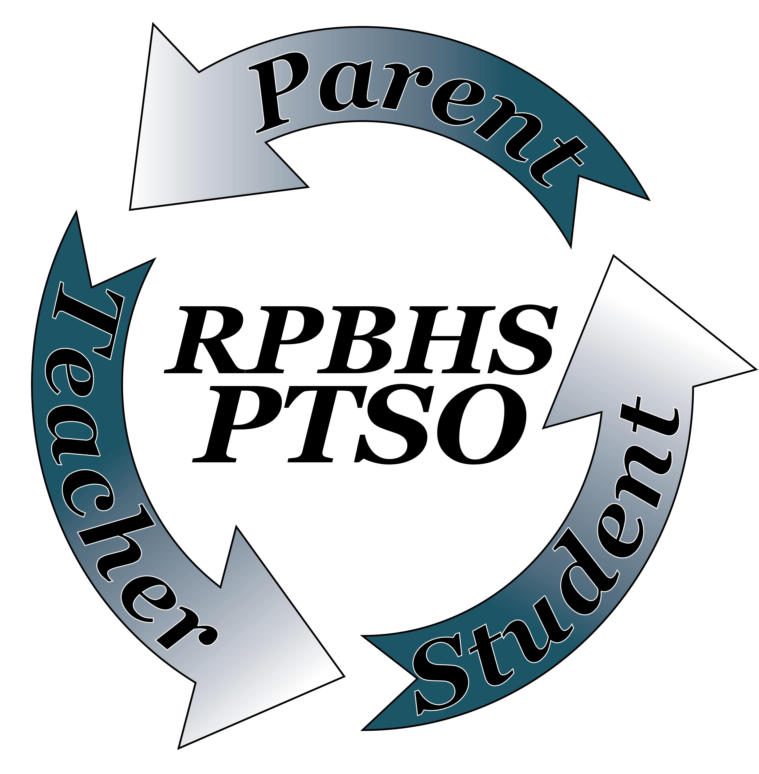 Royal Palm Beach High School
Parent Teachers Student Organization
2016 - 2017

Royal Palm Beach High School PTSO Membership

You are invited to join the Royal Palm Beach High School PTSO (Parent-Teacher - Student Organization)!

Here are some examples of what your PTSO will be working on this school year:

- School Project grants, technology grants. Landscape grants
- New LED Information Sign
- Fundraising Events
- RPBHS PRIDE SHIRTS

Your PTO needs your unique talents, whether it’s volunteering a few hours a month or a few hours a year, serving on the board, or attending meetings. Come join us!

For questions, please visit our website. ( RPBHSPTSO@gmail.com )

------------------------------------------------------------------------------------------------------------------------------------------------
Royal Palm Beach High School PTSO Membership
- Family $5
- Teacher or Student $2
Make checks payable to Royal Palm Beach High School PTSO.

Please return this completed form with payment to the front office. Thanks!

Name Parent-Teacher - Student: ________________________________________
Name Parent-Teacher - Student: ________________________________________
Phone number: __________________________________________________________________________________
Email address: ___________________________________________________________________________________
Child's name: ___________________________________________________________________ Grade: __________
Child's name: ___________________________________________________________________ Grade: __________
Child's name: ___________________________________________________________________ Grade: __________

